MODULE 4 Lesson 1:

Arithmetic & Geometric Sequences

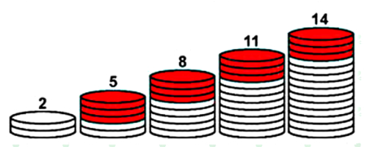

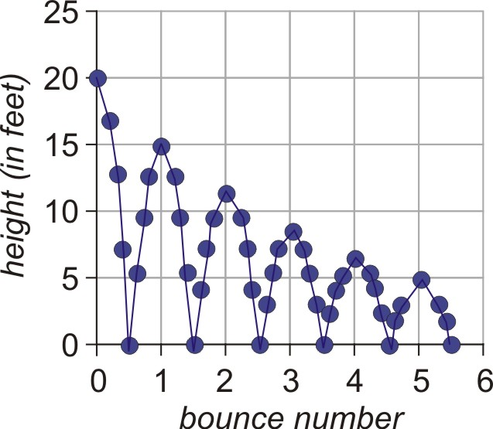

9.1 Mathematical Patterns

A sequence is ……

Arithmetic (has a common difference, d) Geometric (has a common ratio, r)

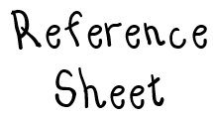
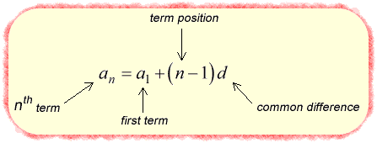
Explicit Formulas (equations) for Arithmetic and Geometric Sequences

Arithmetic Sequences

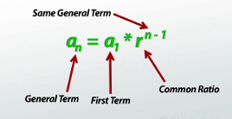

Geometric Sequences

*** BOTH OF THESE ARE ON REFERENCE SHEET FOR REGENTS EXAM ***

Writing Arithmetic/Geometric Sequences

1) 4, 8, 12 , 16… 2) 8, 16, 32, 64…

a_{n} = a₁ + (n-1)(d) a_{n} = a₁(r)^{n-1}

Identify if the following is an Arithmetic or Geometric Sequence, state the common difference or ratio, then write an explicit formula for it.

a) 3, 7, 11, 15… b) 30, 25, 20, 15…

c) 3, 6, 12, 24… d) -5, -2, 1, 4…

e) 64, 16, 4, 1… f) -2, 4, -8, 16…

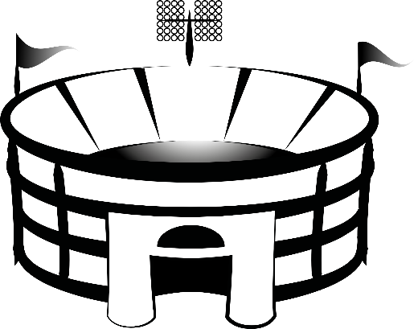
Ex. Row 1 in an arena contains 14 seats. Row 2 in the arena contains 17 seats.
Row 3 contains 20 seats. If this pattern continues,
how many seats will there be in Row 13?

Ex. When Johnny was a year old, his grandparents gave him $50. For each birthday, they increased their
previous gift by $50. If this pattern continued, how much would they give Johnny on his 18th birthday?

Recursive Sequences

A recursive sequence is ……

Example 1: Find the first four terms of the sequence: $a_{1}=2$, $a_{n}=a_{n-1}+6$. Is this an example of an arithmetic or geometric sequence? Explain.

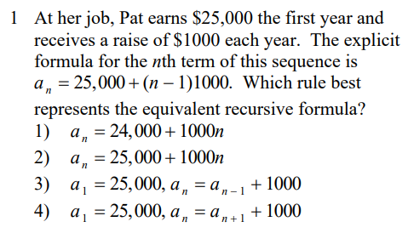
Regents Questions on Recursive Sequences…

